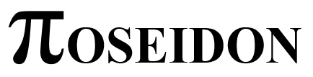
Solution Architecture



Version : 1.0
Version Date : 10 november 2014
Last modified : 10 november 2014
Document details
Contributors
Name | Role | Organization

Bram Havers | Architect | IBM

Index

1 Introduction 4
1.1 About the Poseidon project 4
1.2 Objective 5
1.3 Audience 6
1.4 Scope 6
1.5 Approach 6
2 Vision & Roadmap 7
2.1 Introduction 7
2.2 Problem Statement 7
2.3 Position Statement of Poseidon 7
2.4 Architecture Overview 7
2.5 Architecture Principles 9
2.6 Stakeholder Summary 9
2.7 System Context Diagram 10
2.8 Needs and Features 11
2.9 Requirements 11
2.10 Roadmap 12
3 Solution Architecture Iteration 1 – Poseidon@School 13
3.1 Introduction 13
3.2 Objectives 14
3.3 Deliverables 14
3.4 Architectural decisions 15
3.5 Use case Model 15
3.6 Functional Components derived from use cases 16
3.7 Physical locations 17
4 Solution Architecture Iteration 2 – Poseidon@Farm 18
4.1 Introduction 18
5 Solution Outline – Final 19

Introduction

About the Poseidon project
Poseidon aims to reduce the overuse of fresh water in the world. Did you know that the average cup of coffee averages 140 L of water? Or that a cotton shirt is 3100 L of water? We call this "Virtual Water", see poster in appendix A.

Most of the Water Footprint of the EU (that is, our total use of water), is in countries outside the EU. Most prominently, in Central Asia, which suffer under tremendous water stress and are depleting their natural sources fast. The most striking example is the Aral Sea, which is drying out in a rapid pace, leaving nothing but dry desert on the land which was once ocean
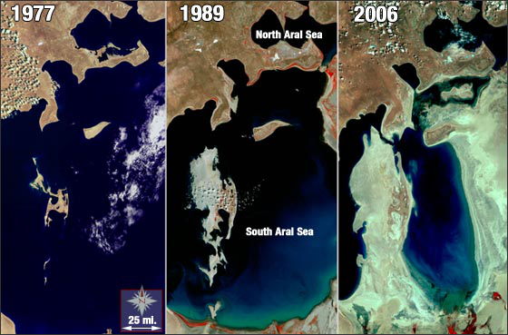
Figure 1 Aral sea drying out

The Poseidon project aims to make a change in all of this by creating awareness through education and marketing and providing assistance by developing low cost open source devices connected to an IBM Bluemix platform to assist local farmers in more efficient irrigation. We call this precision agriculture.

The project is a voluntary initiative that creates actionable insight for farmers to reduce water usage. The Poseidon solution will monitor the environment and collect the data in the cloud where it will be available for scientist to develop new insights. The solution will be easy to use through mobile devices. Scientists and application developers can easily extend the solution with new functionality because the data will be available as Open Data, and will be accessible by systems through API´s.
The solution will be based on the IBM Bluemix cloud platform to scale up as the need for data and computational resources increases.

The Poseidon project is the first project of the Dutch Courage foundation to educate students at 15 universities throughout Asia about the use of this technology. A part of the team will be driving through Asia (Russia, Mongolia, Kazakhstan, Uzbekistan and other countries) to provide this education. The objective is to stimulate students to join the community and extend the Poseidon platform.
In the process of this trip, we expect to lecture at some 15 universities in the region, challenging them to work with us on this global problem, if you would like to spread the word, feel free to use our education material and/or messaging. Together we can change the world!
During our trip we will be blogging and communicating through the following websites:

More information on:
- The Dutch Courage, the charity hosting the project;
- The Poseidon Community for collaboration
(ask Wing for access)
- About Poseidon brochure

Objective
The objective of the Dutch Courage foundation is to reduce the water footprint through education. The Poseidon Project enables this objective by providing a water monitoring solution.
Currently we are focused on the first iteration of the project until the end of 2014. The objective for the first iteration is focused on education and community building. Later iterations increasingly work towards a production ready solution for environment monitoring and decision making.

First iteration objectives
The objective of the first iteration of Poseidon is to:
- Develop a water monitoring solution for educational purposes.
- Deliver education material for building the solution
- Build and support a community of cross discipline enthusiasts (scientists, hydrologists, agriculture experts, application developers, hardware experts, etc)
This iteration delivers a starter solution for experimentation and stimulates others to extend it, in order to facilitate the creation of ‘production-ready’ products.

Long-term objectives
On the long-term the Poseidon objective is to
- Offer a platform to host and distribute Climate Change related data (as Open Data).
- Offer a platform that can easily be extended with technologies known by the student and science community
- Grow re-useable Bluemix services (like specific models) that will speed up the development of new science.

Audience
This document is written to understand the technical aspects of the Poseidon solution. It is relevant for everybody that has an interest in Poseidon and would like to understand the architecture.

Scope
This document defines the architecture and technical design for the Poseidon project.

Approach
For a structured and iterative approach the project follows the Eclipse Open Unified process method. See the Eclipse OpenUP website for a background of this method. Paragraphs in this document are based on the work products from that method. Planning of work will be done on IBM DevOps Track & Plan: https://hub.jazz.net/project/bbhavers/PoseidonProject/track
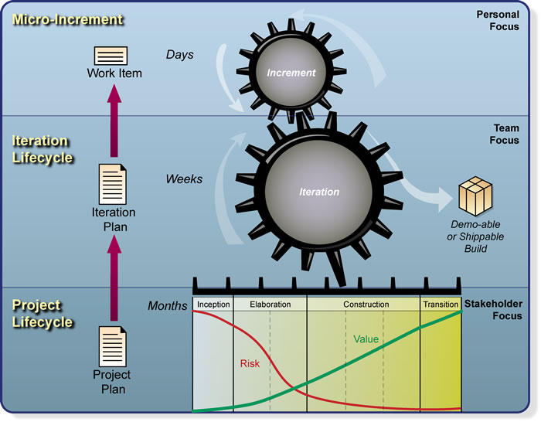
Figure 2 Eclipse Unified Process

Vision & Roadmap

Introduction
The vision paragraph defines the end state of the envisioned Poseidon solution. This vision will be realized in various iterations. The solution will evolve through these iterations to realize the vision.

Problem Statement
The problem statement summarizes the problem being solved by this project.

The problem of | Water scarcity through a changing climate and misuse of natural resources
affects | Agriculture (farmers)
the impact of which is | Reduce effectiveness of agriculture, ultimately leading to conflicts
a successful solution would be | Provide actionable advice to more efficiently use the available (water) resources based on factual data.

Position Statement of Poseidon
This position statements provide an overall statement summarizing, at the highest level, the unique position the product intends to fill in the marketplace.

For | Agriculture (farmers)
Who | Need better advise on their water usage
The (product name) | Poseidon platform
That | Provides water usage advise and freely accessible factual data about the environment
Unlike | The current lack of solutions and availability of data in the current situation
Our product | will be an easy entry solutions for farmers, that the global community of scientists can extend to build a better world.

Architecture Overview
The Poseidon Project aim to provide two types of solution approaches:
- a ready-made product, including a plant monitoring device, a platform to store and distribute sensor data and the applications to analyse the data, share it on social platforms and mobile devices
- tutorials to extend the Poseidon solution by becoming member of the team, or build their own solutions.

The code, data and design documents and tutorials for the ready-made product are publicly available (open source, Open Data). The Poseidon Project wants to stimulate free and open use to maximize experimentation. Everybody can join the project and extend the solution, or take the code and examples and build their own monitoring solution that change the world.

Architecture overview below highlights the key aspects of the Poseidon Architecture.

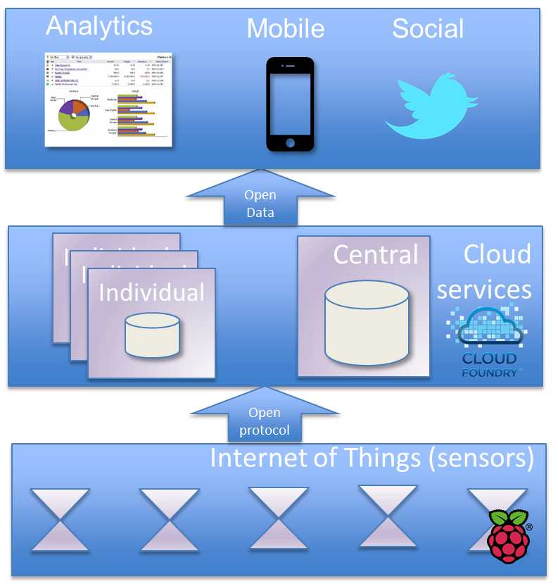
Figure 3 Architecture Overview Poseidon Project

The Internet of Things layers holds the sensors. The Poseidon Project provides an example implementation of a in-house plant monitoring (sensor) solution based on the Raspberry Pi. Other monitoring solutions are supported as well. The sensors will send their data by an open, and sensor data optimized, protocol to the a cloud environment.

The cloud environment holds the central data store and data distribution mechanism. The Poseidon Project will maintain one central cloud environment to continuously capture and distribute the sensor data. This design and tutorial to build this platform are publicly available so users can also start their own Indivual cloud environment to experiment and build new innovations.

To show the potential the Poseidon Project will provide a mobile app that visualizes the monitoring data. The data will be analyzed for triggers (time to water the plant). A forecasting model will analyze the data and provide a planning for watering the plant, a start for precision agriculture.
To stimulate good caring of your plant, the watering times will be made publicly available on social media.

Architecture Principles
In order to reach the objective of the Poseidon project, the solution will have the following characteristics:
- Easy entrance
Poseidon will make it easy for anybody to join the project, this is reflected in all aspects, like description of tutorials, technology choices and design decisions.
- Stimulate experimentation
We want to excite and provide as many people to try this hands-on and submit ideas, design concepts or code.
- Open architecture
Design and code will be available so people can understand and extend the technology.
- Low cost
We want to keep the barrier for entrance low, and so the cost for experimenting.

System Context Diagram
The System Context Diagram describes the solution as a blackbox and highlights the external actors (systems and people) that interact with the solution, see figure below.

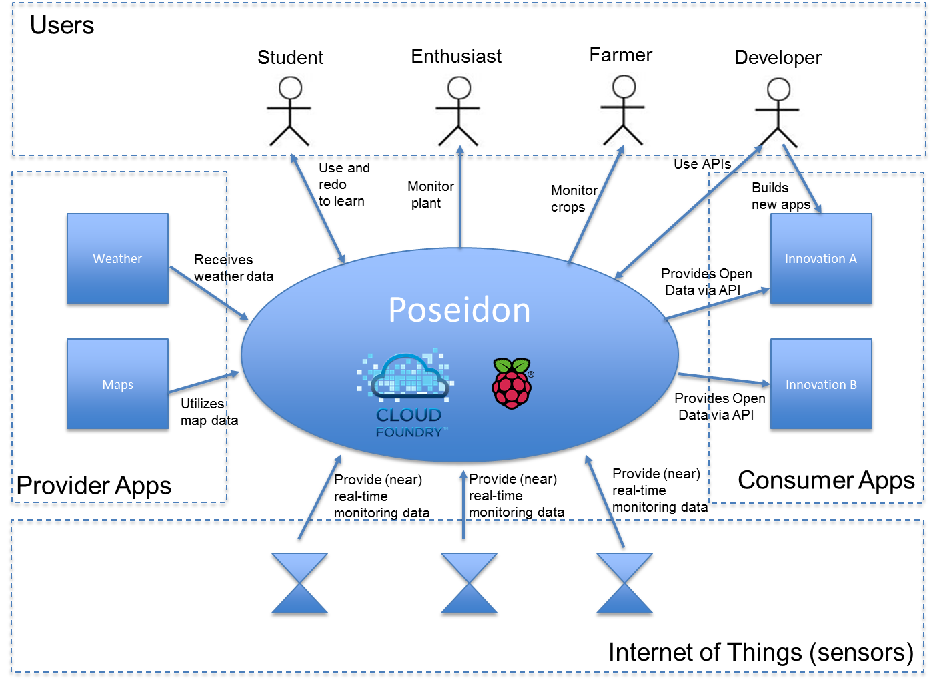
Figure 4 System Context Diagram Poseidon Project

The Poseidon solution is described at the Architecture Overview paragraph above. Here we will describe the actors that interact with the Poseidon solution

Users
 | Student | Use the provided tutorials to learn about the technology for the end-to-end flow from sensor to application. We hope we stimulate the student to become an developer and create innovative solutions
 | Enthusiast | Mainly home users who like the idea of Poseidon. They will follow the instruction to setup the monitoring solution and monitor their plant. They are non-technical. Poseidon stimulates them to submit ideas and, spread the word and take initiative to improve the world
 | Farmer | Will use Poseidon to monitor their crops and receive precision agriculture forecast that improves their farming results while reducing their footprint.
 | Developer | Extends the Poseidon platform in any way. This could be enhancing its functionality or producing better results. A developer could also use the concepts of Poseidon and independently build their own solution. Either way is fine, if it creates a better world.
Internet of Things (Non Poseidon sensor)
 | Sensors | All monitoring solutions that send data. As long as they use the specified protocol and format, their data will be included.
Providing apps
 | Weather | This is an example, any system could be providing data that is interesting to merge with the monitoring data. In this example, weather data is integrated in Poseidon to support the forecasting model to find the best moment for precision agricultate.
 | Maps | Another example. A mapping service will provide graphical maps to visualize position of crops or sensors
Consumer apps
 | Innovation A | We have no clue yet. Anybody with a great idea can use the data inside the central Poseidon instance for their new innovation. We hope to stimulate others to come up with new and great application that improve the world.

Needs and Features
This paragraph provides general feature needs (capabilities) that need to be provided by the solution.

Need | Features
Monitoring device | Monitor the local weather  Monitor the environment (soil, water flow)
Data storage and access infrastructure | Store data from monitoring solution  Make data available for others to develop insight and applications on.
Water usages advise application | The advise should be available on a mobile devices

Requirements
At a high level this paragraph lists the applicable standards, hardware, or platform requirements; performance requirements; and environmental requirements.

Requirement | Description
Open Data | Data must be available as Open Data (no limitation on usage) to accelerate science development that can lead to new insights and advise
Scalable | Start small, but be able to scale solution when data and computational need increases
Usability for end user | Easy for end-users to use
Usability for developer | Easy for scientist and application developers to use
Open Interfaces | The platform is open for everybody through Open API´s

Roadmap
We need a couple of iterations to realize the vision. Because the solution is based on voluntary effort we would like to make each iteration a relative small amount of work with tangible objectives that can be realized in a short amount of time. We will add complexity as we go along.

Challenges for the each iteration

Iteration 1 (end of 2014):
- Get the basic solution end to end (from sensor to mobile device) working in a simplified solution
- Deliver education material (tutorials) on the end to end solution, so others can extend the Poseidon platform.

Iteration 2 (half 2015):
- Connect more monitoring devices and sensors
- Improve functionality of advice applications, and publish a first version in app stores for general beta testing.
- Scale the platform to contain sensor data
- Improve the scientific models to provide better advise

Iteration 3 (end of 2015):
- Improve usability and visual appearance of apps, they should now become ‘production’ ready.
- The platform is managed, new versions will not disrupt earlier versions and availability is guaranteed.

Other iterations might be needed to implement the vision, but will be defined when there is a clearer view on requirements and direction.

Solution Architecture Iteration 1 – Poseidon@School

Introduction
In the first iteration of the Poseidon project we will develop a solution and education material for monitoring the soil moisture of plants. When the soil is to dry, it will send a twitter message and notification to the plants owners mobile. The data will be stored in a cloud platform and made available on a mobile phone. This data will be analyzed by a model developed by universities that will notify the user in advance that watering is needed. As these models take time to do the calculations, the education material will end with an example how to scale up computational resources in the cloud at peak moments.

The scenarios above will be described in detail in use cases. The use cases will be analyzed for functionality and data structures. This will lead to a component model that defines the functional components that need to be implemented. The setup, configuration and development of these components is the foundation of the tutorials that will be delivered at the end of this iteration. In the tutorial we will show step by step how to build such a solution.
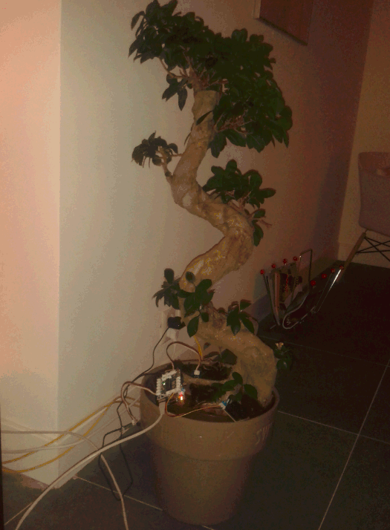
Figure 5 Monitoring and twittering plant

Objectives
The objective for this iteration it is to:
- Deliver a monitoring device based on Raspberry Pi.
- Deliver a central platform to store sensor data and send out tweets based on configurable threshold values.
- Setup the development environment for developing applications and sharing the source code.
- Delivering three tutorials (on IBM developerWorks) that helps others understand the technology and extend the Poseidon solution.

Deliverables
The deliverables are three tutorials

# | Name | Description | Theme
1 | Soil moisture monitoring stations | A low cost soil moister solution for plants at home. This can later be extrapolated to industrial soil moister sensors for agriculture.  The monitoring solution will capture and cache monitoring data and sends it periodically to a central data store.  The data store will publish data of a variety of sensors to social media for interested listeners. | Internet of Things,  Social
2 | Mobile visualization of data and notification | Data will be stored in the central platform  An Open API will be available to provide data, and to acquire data from the data store  A device-independent app visualizes the real-time data  An alarm is set on the data that will notify the user when it is watering time for their plant. | Mobile
3 | Contributing to Poseidon use DevOps | A description of the DevOps online development environment.  Improving the code and sharing this with the community  This tutorial will help you share your improvements with others. | DevOps
4 | Scaling computational needs  (optional, currently not included in any of the iterations) | A simple analytical model will forecast what is the optimal time is for watering the plant  To speed up the time of forecasting reports, the solution will be scaled to 10 cloud instances. This will decrease the computational time for crisis situations. | Analytics & Cloud elasticity

Architectural decisions
To realize the objective we have made the following decisions
- The monitoring prototype will use Raspberry Pi components.
This is a low-cost and easy to start platform for monitoring that is designed for educational purposes and therefore fits very well with the projects objectives.
- The cloud environment to be used will be IBM Bluemix for the central place to store and distribute data.
- The development environment will be IBM DevOps for central storage of source code. DevOps will also be used as online development environment, although users can use an offline environment if the wish to do so.

Use case Model
The use cases describe the functionality needed by the end user and how the user and other system will interaction with the future solution.

See the tutorials for the entry-level use cases.
The the Poseidon overview presentation for the long-term visionary use cases (precision agriculture).
.

Functional Components
Functionality identified in the use cases will be grouped in Functional Components. These components will need to be developed or configured to make the solution work. The Component Model (functional decomposition) provides an functional view of the solution.

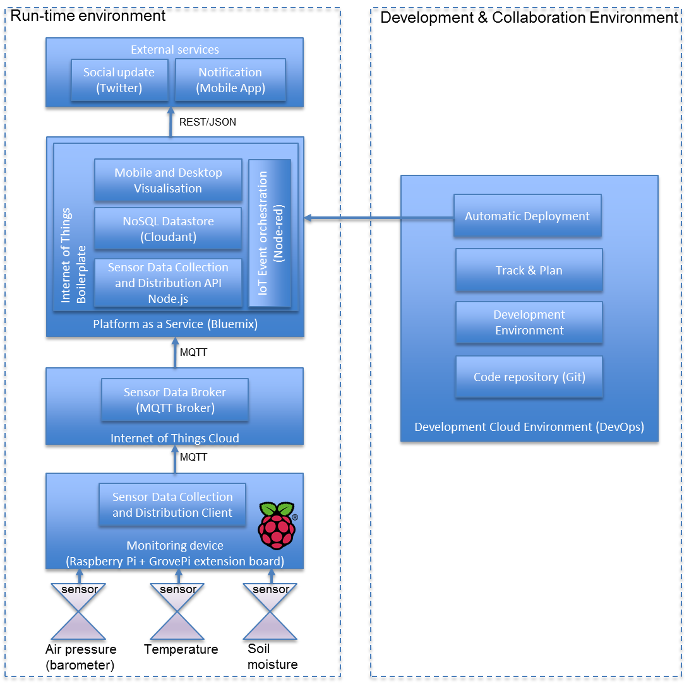
Figure 6 Poseidon Component Model (functional decomposition)

The following Functional Components have been identified for the run-time environment.

Component | Description
Monitoring device | The hardware that collects sensor data (Raspberry Pi + GrovePi extension board)
Sensors | The sensors that collect the data (Soil moisture sensor + air pressure (barometer) + temperature)
Sensor Data Collection and Distribution Client | A client component that collects data from sensors and sends it to the Internet of Things Cloud.
IoT Cloud / Sensor Data Broker | A centralized service on the internet that receives sensor data and distributed this to subscribed clients
Internet of Things Boilerplate | A combination of services to collect, store and process internet of things events.
Sensor Data Collection and Distribution API | An API that collects sensor data from the cloud broker and makes it available internal and external (as Open Data) to the Poseidon platform
Sensor data storage | A datastore to hold the sensor data
Mobile and Desktop Visualisation | A mobile and desktop browser user interface that lists the available sensors in the data store and a graph of the sensor data
IoT Event orchestration | This components ‘wires’ all components in the platform visually together. It is driven by events (eg. sensor data coming in). It groups functionality in re-usable components called nodes.
Notification | Notifies the end-user on his mobile service that their plant needs watering.
Social update | An update to social media that their plant needs watering.

To collaboratively plan and develop the solution the following development environment is needed, based on IBM DevOps.

Component | Description
Code repository | The place to store code for the whole solution (client on the monitoring device, and code for the Bluemix platform. Code will be versioned.
Development Environment | A cloud development environment that can be used with your web browser. No need to setup your own local development environment.
Track & Plan | A service to plan the development activities, assign them to team members and track progress. Also includes functionality for feature or bug tracking.
Automatic Deployment | Code changes to the components that run on Bluemix will be automatically deployed to the Bluemix environment.

Physical locations
The Poseidon solution span four physical areas of focus:
- Monitoring device
Decentralized and located near the plan to be monitored
- Internet of Things cloud
A service on the internet that accepts sensor data and redistributes this to subscribers. Various services exist on the internet. No guarantees are provided for the free services that we will use.
We will use the ngi.realtime.ibm.com broker. An alternative is broker.mqttdashboard.com.
- Platform as a service
This is the centralized platform for collection of data and running your applications. We will run on the IBM Bluemix platform, which is based on the open Cloud Foundry framework.
This framework consists of various services of which one is a datastore. We will use Cloudant as a data store.
- External services
We will use external services like Twitter to publish data and notifications.

Solution Architecture Iteration 2 – Poseidon@Farm

Introduction
Iteration two has not been defined yet. Text below is from an email with a first indication of what phase 2 could look like.

The real-life case for Poseidon envisions two or three testfields with real sensors, assume 50x3 measurement points per field. The overall architecture will be similar to the above, except we will add weather data (wunderground) and a NodeJS instance to visualise the data and load the data from the Wunderground apis. Moreover, the models developed will be more intense.

Data assumptions:
50x6x3 = 450 measurements per 15 mins, will be around 86400 sensor readings per day, i.e. 31535000 per year. Not sure how these numeric data would end up in Informix, but I assume it wouldn't be too large (around 3 gb).

Next to this, we would enrich with overall data from Wunderground, adding hourly weather predictions from a range of weatherstations. This would include precipation (one wouldn't irrigate when rain is expected), humidity, wind, etc. We are still desiging the overall data flow for this. Assume it will be similar in size (regional prediction) to the data from the sensors, making the yearly requirement some 6GB in storage.

Moreover, we would store data on administration, geolocation, etc.; assume we will reach a max of 10GB in storage in the first year (so untill end 2015).

Mobile App
The app for farmers will get realtime push messages when irrigation is deemed necessary by the system. Similarly to the School module, we will first start with treshold based triggers and gradually move towards analytics and planning.
We assume some 20 app users (students, farmer, etc) per farm, totalling some 60 users.

Analytics
We would run spatio-temporal analytics upon the informix timeseries, if I am not mistaken there is a service for that? The model would be computationally intensive I suppose, not sure how to calculate this towards GB/Hrs.

Web
The complete project will be visualised through a NodeJS website, where data can be visualised and realtime data from farms can be observed by the general public. Assume we have a nodeJS instance running and we would receive some 1000 visitors daily, I guess we would need to scale?

Solution Outline – Final
TBD

Appendix
